**SMIT R PATEL**

**19162121031**

**SEM 5**

**BIG DATA AND ANALYTICS**

**PRACTICAL 5**

Given below is the data regarding the electrical consumption of an organization. It contains the monthly electrical consumption and the annual average for various years.

|  |  |  |  |  |  |  |  |  |  |  |  |  |  |
| --- | --- | --- | --- | --- | --- | --- | --- | --- | --- | --- | --- | --- | --- |
|  | **Jan** | **Feb** | **Mar** | **Apr** | **May** | **Jun** | **Jul** | **Aug** | **Sep** | **Oct** | **Nov** | **Dec** | **Avg** |
| 1979 | 23 | 23 | 2 | 43 | 24 | 25 | 26 | 26 | 26 | 26 | 25 | 26 | 25 |
| 1980 | 26 | 27 | 28 | 28 | 28 | 30 | 31 | 31 | 31 | 30 | 30 | 30 | 29 |
| 1981 | 31 | 32 | 32 | 32 | 33 | 34 | 35 | 36 | 36 | 34 | 34 | 34 | 34 |
| 1984 | 39 | 38 | 39 | 39 | 39 | 41 | 42 | 43 | 40 | 39 | 38 | 38 | 40 |
| 1985 | 38 | 39 | 39 | 39 | 39 | 41 | 41 | 41 | 00 | 40 | 39 | 39 | 45 |

If the above data is given as input, we have to write applications to process it and produce results such as finding the year of maximum usage, year of minimum usage, and so on. This is a walkover for the programmers with finite number of records. They will simply write the logic to produce the required output, and pass the data to the application written.

But, think of the data representing the electrical consumption of all the largescale industries of a particular state, since its formation.

When we write applications to process such bulk data,

• They will take a lot of time to execute.

• There will be a heavy network traffic when we move data from source to network server and so on.

To solve these problems, we have the MapReduce framework.

Input Data

The above data is saved as **sample.txt** and given as input. The input file looks as shown below.

1979 23 23 2 43 24 25 26 26 26 26 25 26 25

1980 26 27 28 28 28 30 31 31 31 30 30 30 29

1981 31 32 32 32 33 34 35 36 36 34 34 34 34

1984 39 38 39 39 39 41 42 43 40 39 38 38 40

1985 38 39 39 39 39 41 41 41 00 40 39 39 45

Example Program

Given below is the program to the sample data using MapReduce framework.

package hadoop;

import java.util.*;

import java.io.IOException;

import java.io.IOException;

import org.apache.hadoop.fs.Path;

import org.apache.hadoop.conf.*;

import org.apache.hadoop.io.*;

import org.apache.hadoop.mapred.*;

import org.apache.hadoop.util.*;

public class ProcessUnits {

//Mapper class

public static class E_EMapper extends MapReduceBase implements Mapper<LongWritable ,/*Input key Type */

Text, /*Input value Type*/

Text, /*Output key Type*/

IntWritable> /*Output value Type*/

{

//Map function

public void map(LongWritable key, Text value, OutputCollector<Text, IntWritable> output,

Reporter reporter) throws IOException {

String line = value.toString();

String lasttoken = null;

StringTokenizer s = new StringTokenizer(line,"\t"); String year = s.nextToken();

while(s.hasMoreTokens()) {

lasttoken = s.nextToken();

}

int avgprice = Integer.parseInt(lasttoken); output.collect(new Text(year), new

IntWritable(avgprice));

}

}

//Reducer class

public static class E_EReduce extends MapReduceBase implements Reducer< Text, IntWritable, Text, IntWritable > {

//Reduce function

public void reduce( Text key, Iterator <IntWritable> values,

OutputCollector<Text, IntWritable> output, Reporter reporter) throws IOException {

int maxavg = 30;

int val = Integer.MIN_VALUE;

while (values.hasNext()) {

if((val = values.next().get())>maxavg) { output.collect(key, new IntWritable(val)); }

}

}

}

//Main function

public static void main(String args[])throws Exception { JobConf conf = new JobConf(ProcessUnits.class);

conf.setJobName("max_eletricityunits");

conf.setOutputKeyClass(Text.class);

conf.setOutputValueClass(IntWritable.class); conf.setMapperClass(E_EMapper.class);

conf.setCombinerClass(E_EReduce.class);

conf.setReducerClass(E_EReduce.class);

conf.setInputFormat(TextInputFormat.class);

conf.setOutputFormat(TextOutputFormat.class);

FileInputFormat.setInputPaths(conf, new Path(args[0])); FileOutputFormat.setOutputPath(conf, new Path(args[1]));

JobClient.runJob(conf);

}

}

Save the above program as **ProcessUnits.java.** The compilation and execution of the program is explained below.

Compilation and Execution of Process Units Program

Let us assume we are in the home directory of a Hadoop user (e.g. /home/hadoop). Follow the steps given below to compile and execute the above program.

Step 1

The following command is to create a directory to store the compiled java classes. $ mkdir units



Step 2

Download **Hadoop-core-1.2.1.jar,** which is used to compile and execute the MapReduce program. Visit the following link mvnrepository.com to download the jar. Let us assume the downloaded folder is **/home/hadoop/.**

Step 3

The following commands are used for compiling the **ProcessUnits.java** program and creating a jar for the program.

$ javac -classpath hadoop-core-1.2.1.jar -d units ProcessUnits.java

$ jar -cvf units.jar -C units/ .

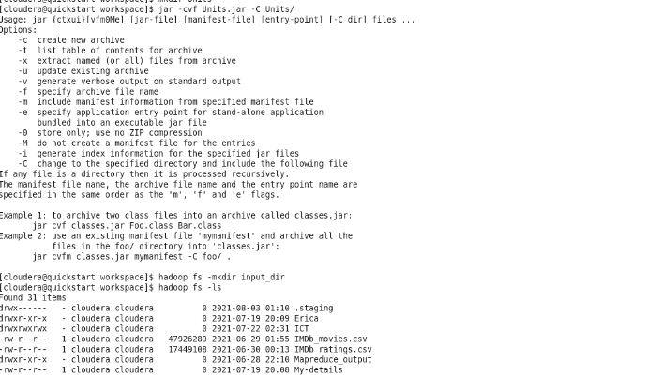

Step 4

The following command is used to create an input directory in HDFS. $HADOOP_HOME/bin/hadoop fs -mkdir input_dir



Step 5

The following command is used to copy the input file named **sample.txt**in the input directory of HDFS.

$HADOOP_HOME/bin/hadoop fs -put /home/hadoop/sample.txt input_dir

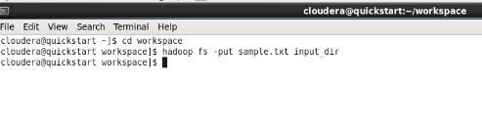

Step 6

The following command is used to verify the files in the input directory. $HADOOP_HOME/bin/hadoop fs -ls input_dir/

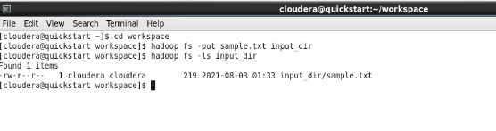

Step 7

The following command is used to run the Eleunit_max application by taking the input files from the input directory.

$HADOOP_HOME/bin/hadoop jar units.jar hadoop.ProcessUnits input_dir output_dir

Wait for a while until the file is executed. After execution, as shown below, the output will contain the number of input splits, the number of Map tasks, the number of reducer tasks, etc.

INFO mapreduce.Job: Job job_1414748220717_0002

completed successfully

14/10/31 06:02:52

INFO mapreduce.Job: Counters: 49

File System Counters

FILE: Number of bytes read = 61

FILE: Number of bytes written = 279400

FILE: Number of read operations = 0

FILE: Number of large read operations = 0

FILE: Number of write operations = 0

HDFS: Number of bytes read = 546

HDFS: Number of bytes written = 40

HDFS: Number of read operations = 9

HDFS: Number of large read operations = 0

HDFS: Number of write operations = 2 Job Counters

Launched map tasks = 2

Launched reduce tasks = 1

Data-local map tasks = 2

Total time spent by all maps in occupied slots (ms) = 146137 Total time spent by all reduces in occupied slots (ms) = 441 Total time spent by all map tasks (ms) = 14613 Total time spent by all reduce tasks (ms) = 44120 Total vcore-seconds taken by all map tasks = 146137 Total vcore-seconds taken by all reduce tasks = 44120 Total megabyte-seconds taken by all map tasks = 149644288 Total megabyte-seconds taken by all reduce tasks = 45178880

Map-Reduce Framework

Map input records = 5

Map output records = 5

Map output bytes = 45

Map output materialized bytes = 67

Input split bytes = 208

Combine input records = 5

Combine output records = 5

Reduce input groups = 5

Reduce shuffle bytes = 6

Reduce input records = 5

Reduce output records = 5

Spilled Records = 10

Shuffled Maps = 2

Failed Shuffles = 0

Merged Map outputs = 2

GC time elapsed (ms) = 948

CPU time spent (ms) = 5160

Physical memory (bytes) snapshot = 47749120

Virtual memory (bytes) snapshot = 2899349504

Total committed heap usage (bytes) = 277684224

File Output Format Counters

Bytes Written = 40

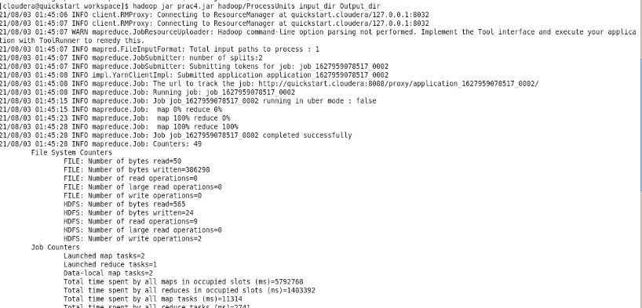

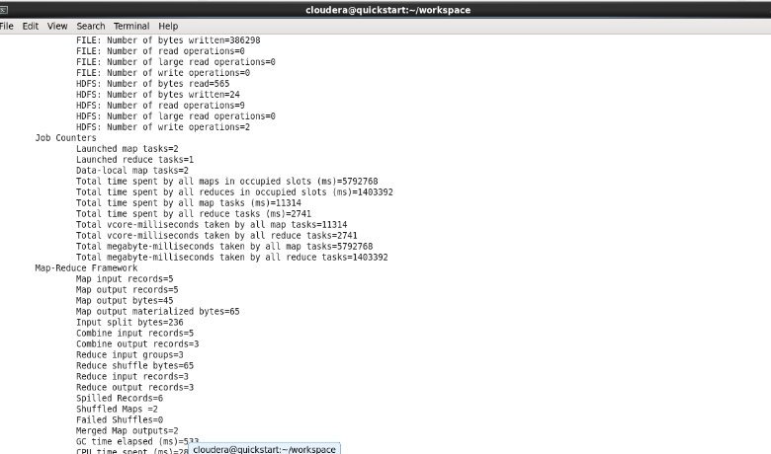

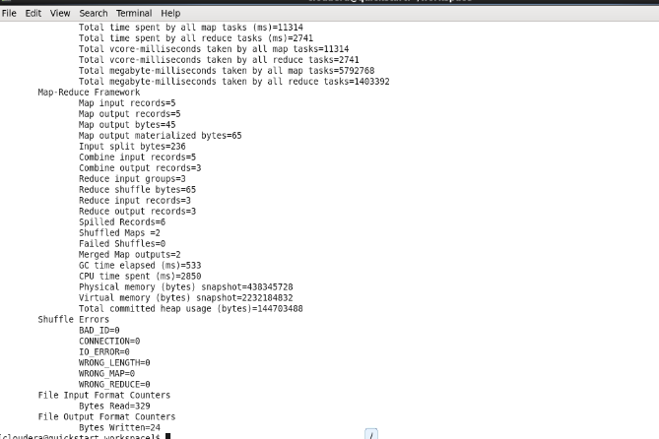

Step 8

The following command is used to verify the resultant files in the output folder. $HADOOP_HOME/bin/hadoop fs -ls output_dir/



Step 9

The following command is used to see the output in **Part-00000** file. This file is generated by HDFS.

$HADOOP_HOME/bin/hadoop fs -cat output_dir/part-00000 Below is the output generated by the MapReduce program.

1981 34

1984 40

1985 45



Step 10

The following command is used to copy the output folder from HDFS to the local file system for analyzing.

$HADOOP_HOME/bin/hadoop fs -cat output_dir/part-00000/bin/hadoop dfs get output_dir /home/hadoop